Practical No: 05

**Aim:** Setting up wireless access point using raspberry Pi.

**Hardware Required:**

1. Raspberry Pi 3B+
2. Ethernet Cable
3. Monitor
4. HDMI to VGI convertor
5. Micro SD card (any class best is class 10)
6. Adaptor with 5v 2A
7. USB mouse
8. USB keyboard

**Software Required:**

1. Rapbeian OS
2. RaspAP

**Procedure:**

1. **Hardware Setup:**

* Connect the Ethernet port of raspberry pi to an Ethernet port in a router/switch using the Ethernet cable

1. **Software Setup:**

* Run the following commands in the terminal ….
* *sudo apt update*
* *sudo apt upgrade*
* Install RaspAP by typing the following commands in the terminal…..
* wget -q https://git.io/voEUQ -O /tmp/raspap && bash /tmp/raspap
* Pass Y in every prompt in the terminal
* Reboot the Device
* Open the browser in Raspberry Pi and type the following URL <http://localhost>

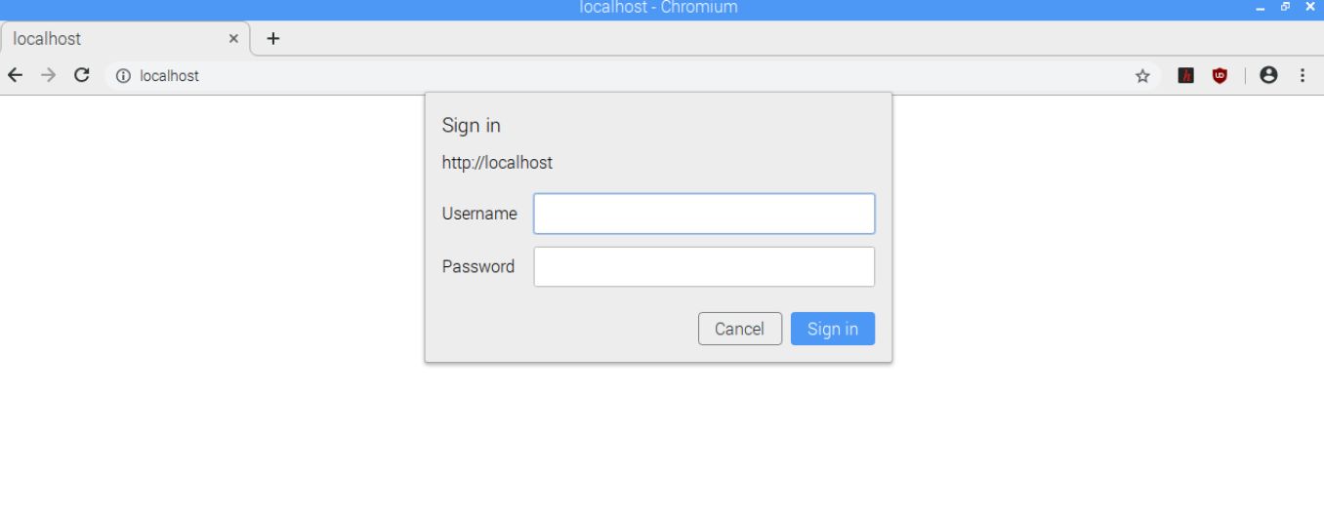

* Enter Username: “admin” and Password: “secret”
* Navigate to “Configure Hotspot”

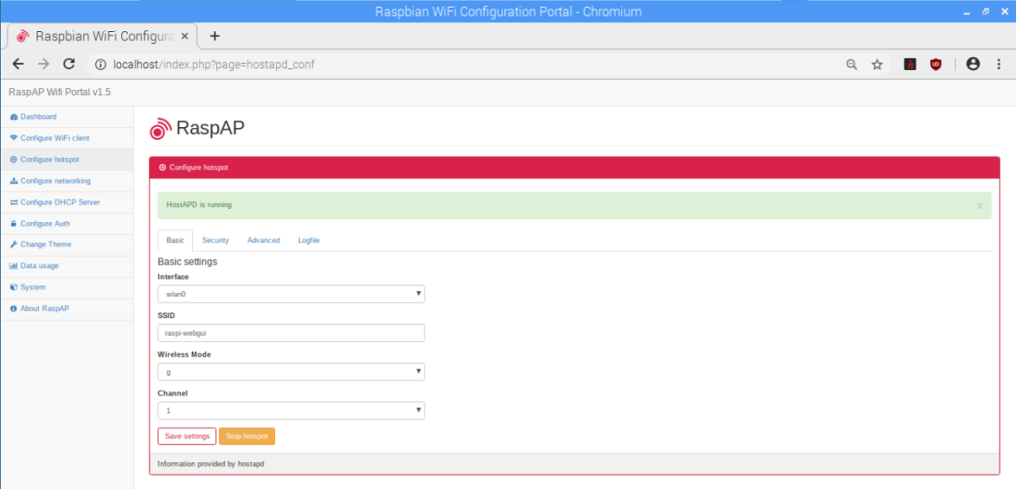

* Set the setting as ….

Interface: wlan0

SSID: **anythingYouWant**

Wireless Mode: g

Channel: anything will do

* Press “Save settings”
* Navigate to System and Press “Reboot”
* Grab your phone and search for your network as you have given in the **SSID.**
* Connect

**Precautions:**

* If it is a fresh flash of Rasbian OS “*sudo apt update”* and “*sudo apt upgrade”* is a must thing.
* SSID name should not be same that of your neighbor.